Personal profile
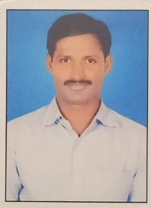
Name : M.RAMESH
Father Name : M.MALAKONDAIAH
Sex : Male
Date of Birth : 04-05-1986
Marital status : MARRIED
Nationality : Indian – Hindu
Caste : BC-D
Educational Qualification : M.P.Ed.
Email : vmkreddy77@gmail.com
Mobile : 9390014104
Professional Experience : Total 4 years
1. Govt.Degree college Udayagiri Dt.2022onwards

